SESSION 8 — Gearhaven
Beat 5 — The Tremor (Fight 3)

Up Into Chaos
The freight-lift can’t carry you up fast enough, so you take the stairs — pounding up flight after flight toward the bells, toward the screaming, Skitch wheezing behind you. You burst out of a service hatch into daylight and noise and panic.
Gearhaven has gone mad.
The ground itself is shuddering — that great heartbeat under the city, Boom… Boom…, has gone fast and wrong, like a heart that’s frightened. Steam-trams hang dead on their cables. Brass shutters slam open and closed by themselves. And the crowd is running — every citizen of Gearhaven pouring through the streets, away from one place in particular.
Skitch points, gasping. “There! Whatever it is — it’s worst over THERE!”
And he’s pointing at the one patch of green in the whole grey city.
Lilly: “The heartbeat’s all wrong — that’s the Great Governor skipping. Something downstairs is feeding straight up into the city. We have to get to the middle of it!”
Stabby: “Everyone’s runnin’ AWAY from the trouble. We’re runnin’ TOWARD it. Feels right!”
Ursa: “That green — that’s the only living thing I’ve felt since we got here. And it’s where it’s worst. Come on!”

The Verdant Plaza
You round the corner and there it is: the Verdant Plaza. In the middle of all that brass and steam, someone long ago built a garden — real trees, real grass, beds of flowers, a wide marble fountain at the center fed by a beautiful old clockwork engine, all of it kept perfect, like a single green jewel set in iron. It’s the most alive place you’ve seen in all of Gearhaven.
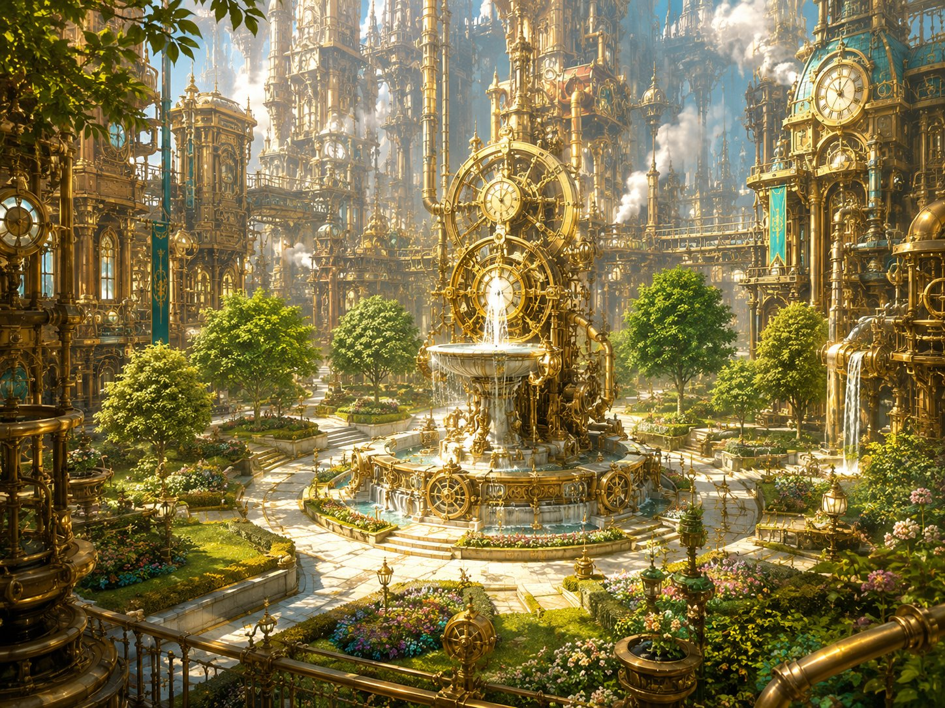
The Verdant Plaza — a single jewel of living green in the heart of the brass city.
And it’s dying in front of you.
The shuddering ground is splitting the lawn. Sick blue-white light — the same light as the rift below — is bleeding up through the cracks. And where that light touches the green, the green goes wrong: grass curls black, flowers wither and twist, a proud old tree groans as gray corruption climbs its trunk and its leaves crumble to ash.
At the fountain’s heart, the garden-engine is screaming — gears spinning far too fast, water boiling, the whole beautiful machine shaking itself to pieces.
▶ Ursa’s spotlight (let it hit him hardest). Of the three, Ursa feels this. He spent Beat 4 aching for something alive, and here is the one living place in the city being un-made in front of him. Don’t make it a mechanic — give him the emotional close-up and the first line. His “I belong with living things, not machines” door deepens just by letting him react.
Ursa (give him this): “No — no, it’s ALIVE, it’s the only thing down here that’s alive — they’re killing it. I won’t let them. Not this.”
Lilly: “It’s that engine — the one running the garden. The surge hit it and it’s tearing itself apart. If I can get to it, I think I can—”
Stabby: “Less talkin’, more— wait.” (His hand goes to his pocket.)

The Idol Stirs — Stabby
Stabby stops dead. The little idol he carries — the one that went cold down by the rift — isn’t just cold now.
It’s pulling.
Tugging in his pocket, hard, dragging toward the cracks in the lawn where the blue light bleeds up, like it wants to go to the corruption. It’s warm on one side and ice-cold on the other, and for just a second, in the back of his head, Stabby hears something — not words, just a feeling, like a voice trying to reach him through deep water.
▶ Stabby’s idol, escalated (plant mystery, don’t explain). This is the upgrade from Beat 4’s “it just goes cold.” Now it actively reacts to the planar surge — pulling, almost communicating. Don’t tell the table what it means. Slow-burn mystery toward his idol-path door and beyond. If Stabby’s player wants to investigate, let them feel it’s connected to the planar stuff — and leave it there.
▶ Stabby’s monk touch (light). Amid the chaos and the creepy idol, drop one beat where Stabby reaches for the stillness Master Kaelon tried to teach him — and this time, maybe, for half a second, finds it. A tightening of the thread, not a resolution.
Stabby (unsettled, rare for him): “My idol’s goin’ nuts. It’s pullin’ toward the bad light. Like it WANTS it. That’s… that’s real creepy, even for me.”
Stabby (the monk touch): “Okay. Okay. Breathe. Master Kaelon said get still. …Huh. There it is. Found it. Now let’s wreck some stuff.”

The Plaza Erupts — Fight 3 Begins
The cracks in the lawn tear wide — and things start climbing out of the dying garden.
First, the small ones: the corrupted plants themselves, pulling free of the soil. Snarls of blackened vine and thorn, knotted around bits of broken gear, scuttling and lashing on root-legs, their flowers turned to gnashing, glowing-blue maws. A dozen of them, skittering toward the fleeing crowd.
Then the ground heaves — and the big ones rise. Three of the city’s great worker-constructs, the Iron Drudges, hauling themselves up out of the maintenance pits, twice as tall as Stabby, their cargo-arms swinging. Where the rogue machines in the market had red eyes, these are worse — gray planar corruption crawls across their iron like rot, and the same sick blue light burns in their cores.
They lurch toward the fountain at the center and ring it — planting themselves between you and the screaming engine, as if the corruption wants to guard the very thing that feeds it. Ghostbloom flares bright and ready at your side. Skitch, white-faced, backs toward the street. “I— I can’t fight THOSE. I’ll get clear, I’ll keep folk back — GO! Do the thing you do!” And he scrambles to safety, leaving the plaza to you.
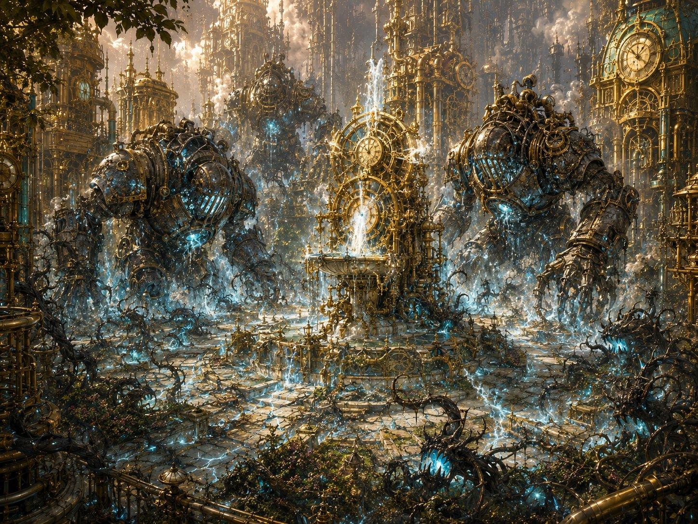
The plaza erupts — Iron Drudges rise and corrupted plants crawl from the dying lawn.
▶ The objective — say it plainly, keep it simple. There is ONE job: get Lilly to the fountain so she can fix the engine. That’s it. The three Iron Drudges are ringed around the fountain, blocking the way — the party has to punch through them. The Sproutlings keep crawling out of the cracks and never stop until the engine is fixed, so don’t bother counting them; they’re just there to nip at the heroes and make the clock feel loud. The fight ENDS the instant Lilly reaches the engine and fixes it (see her moment) — so the whole table knows exactly what they’re doing: clear a path, protect Lilly, get her to the fountain.
Lilly: “You hold them OFF me — all of you — and get me to that fountain. I can fix this, I KNOW I can, I just need thirty seconds and nobody chewing on me!”
Stabby: “Big metal ones first! Crack the ring, make Lilly a door — I’ll keep the little biters off her!”
Ursa: “Stay behind my spirit and my staff, Lilly — we’ll carve you a path to that fountain. Go save the green.”

Running Fight 3 (HARD)
Battlefield (one simple objective). Picture it like a king-of-the-hill: the fountain-engine is the hill, the three Iron Drudges are the wall around it, and the party has to break through and get Lilly to the middle. The Sproutlings spawn from the cracks to keep 6–8 on the field at once (when one dies, another crawls up on the group’s turn) — a steady trickle, never a flood. To keep it easy to run, ALL the Sproutlings act together on one shared initiative: roll once, move them all, resolve their attacks as a group. They’re slow (10 ft), so the heroes can stroll right past them if they want; they’re just there to harry the heroes so the fight feels urgent. Don’t track civilians, don’t offer choices; the whole table is pointed at one thing: clear a path, protect Lilly, reach the fountain. The fight resolves the instant she gets there and fixes it — so let that happen whenever the table’s had enough satisfying combat. Don’t drag it.
Tuning. HARD for a min-maxed level-5 four. The Drudges hit hard and are tanky; the plant-swarm is weak but numerous — there for easy, satisfying kills and to threaten the green (texture). A hero may drop — intended. The Drudges are VULNERABLE TO FIRE (corrupted wood and vine in their joints) — telegraph the smoke; Lilly’s flamethrower cannon and Ursa’s Produce Flame / Flaming Sphere shine. (Deliberate contrast: the market Hauler and the coming boss are lightning-vulnerable; fire here keeps the party rotating tools.)
Ghostbloom. Up here in the open air, away from the rift, Ghostbloom is braver than it was in the Underworks — it darts and shields and heals more confidently. Nice contrast to Beat 4. Give it a hopeful line.
Scaling dials. The simplest dial is the Sproutling cap (raise it toward 8 or lower it toward 6) and how stubbornly the Drudges block Lilly’s path. Too easy: raise the cap toward 8 and have the Drudges body-block the lane to the fountain so the party really has to break the ring. Too hard / a hero is dropping: drop the cap toward 6, let a Drudge be slow to turn so Lilly slips past, or have Ghostbloom spend Guardian’s Light. Remember a Drudge is slow — the party can outrun one to the fountain rather than killing all three.

Lilly’s Moment: The Fix
Read when Lilly reaches the fountain engine.
Lilly skids to the fountain and throws herself at the screaming engine, tools already out. Up close it’s worse — the surge has driven every gear past its limit, blue light pouring from the seams, the whole thing seconds from flying apart.
But Lilly Glimmergear has been taking machines apart since before she could walk.
Her hands move on their own. She sees it — the governor-spring overwound, the regulator jammed wide open, the planar surge screaming through a machine never built to hold it. The same instinct that built her cannon, that her mother trained into her at Glimmerspire, takes over.
“I see you,” she breathes. “I see what’s wrong with you. Hold STILL.”
She jams a frost-charged tool into the regulator. Slams the governor closed. Reroutes the surge — out, away, down into the ground where it can’t hurt anyone. The engine shrieks… stutters… and with a great shuddering sigh, slows. The boiling water settles. The blue light drains out of the cracks. The terrible fast heartbeat under the city eases back toward calm. Boom… Boom… Boom.
The plaza goes quiet. The dying green stops spreading. And every Drudge still standing slumps where it stands as the corruption loses its grip.
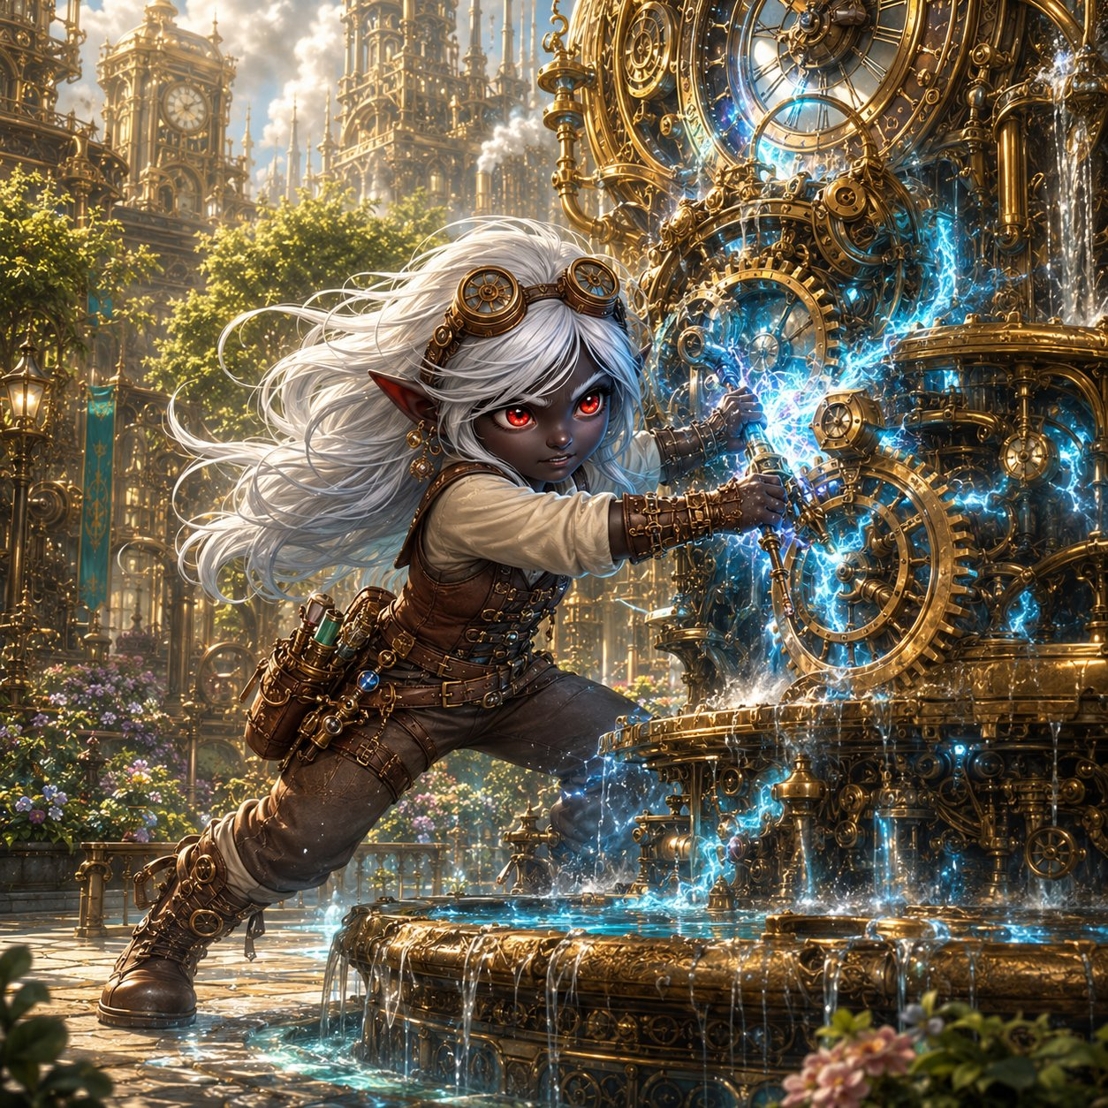
Lilly’s moment — frost-tool to the gears, reading the machine and bending it back to calm.
But as the surge drains away, Lilly’s hands go still on the engine. Because she can feel it now — feel where all that wrongness was flowing from. The corruption didn’t start here. The plaza engine was just a pipe it poured through. And as she traces it, eyes going wide, the path leads up, and up, toward the heart of the whole city.
“This isn’t the source,” she says slowly. “It’s just where it spilled out. The surge is coming from something MUCH bigger. Something that runs the whole city’s clockwork. And it’s…” She turns, follows the pull with her eyes, and her voice goes very small. “…it’s THAT.”
▶ Lilly’s fix now does double duty. She doesn’t just save the plaza; she diagnoses the whole crisis and locates its true source — and that’s what points the party at the boss. A second, bigger payoff for her spotlight, and it means the party walks toward Beat 6 on purpose, led by her read of the machine.
▶ At a kids’ table, don’t gate the climax behind a die roll. If you want a roll for flavor, ask for a single Arcana check and narrate success regardless (a low roll just means it’s hairy, sparks fly, she barely gets it — but she gets it).
Lilly (after, breathless, a little stunned at herself): “…I did it. I actually— I felt what it needed and I just… did it.”
Ursa: “The green’s still alive. You saved it, Lilly. You saved all of it.”
Stabby: “That was the coolest thing I ever saw and I once set my own pants on fire on PURPOSE.”

Vane’s Offer — Lilly’s “Stay” Door
You didn’t even see him arrive. But there’s Guildmaster Vane at the edge of the plaza, white hair wild, goggles askew, having clearly run the whole way — and he’s staring at Lilly like she’s the answer to a question he’s been asking his whole life.
“I have been trying to stabilize a planar surge for ten YEARS,” he says quietly. “I have failed every time. And you — a child — just did it with a frost-tool and your bare hands, in the middle of a battle, in under a minute.” He walks closer, gentle now, careful. “Lilly Glimmergear. I don’t think you understand what you are.”
He kneels down to her height.
“Stay. When this is done — when the world’s a little safer — come back here, to the Guild, and let me teach you everything I know. Help me finish the Rift Portal. Help me unlock that Sphere of yours and learn what the motes truly are. You could be the greatest artificer this city has seen in a hundred years. Your mother gave you a gift, and I could help you become everything it’s pointing toward.”
He sees the look on her face — torn — and softens. “You don’t have to decide now. I’m an old man with a half-built door; I’ll still be here. Just… know that the offer is real. And that there’s a place for you here, whenever you want it.”
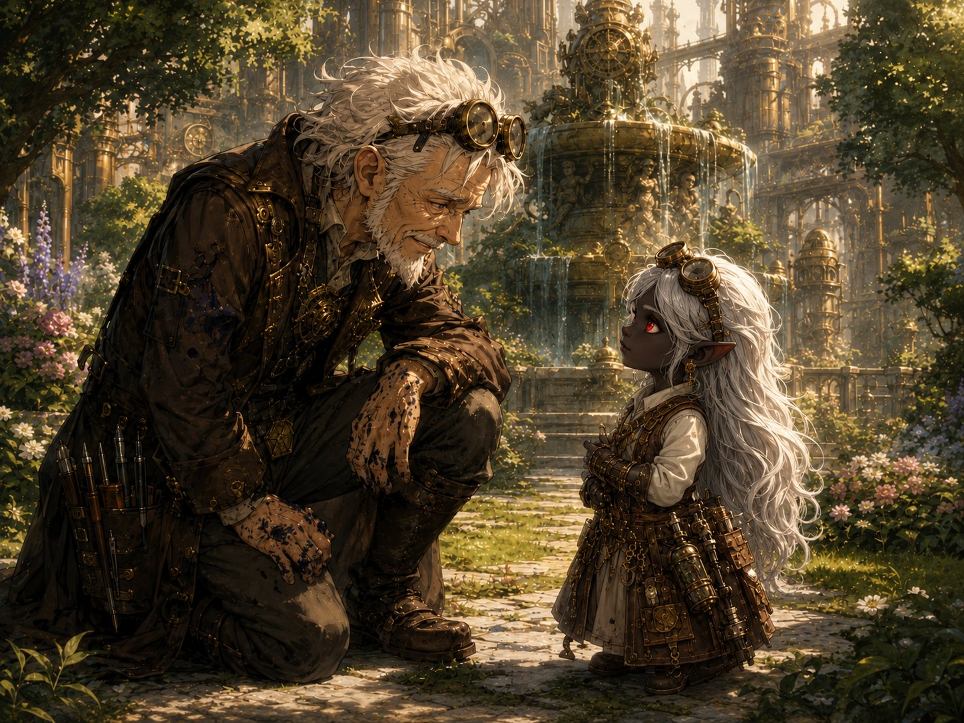
Vane kneels to Lilly’s height — “there’s a place for you here, whenever you want it.”
▶ Lilly’s “stay & build” door — planted and left open. This completes Lilly’s three seeds (Glimmerspire ✓, mote-research ✓ braided in here, “stay & build” ✓). Crucially, Vane says you don’t have to decide now — so the offer hangs over the time-skip rather than forcing an answer. Let Lilly’s player sit with it; don’t push for a response. The pull should be genuinely hard: her mother’s path, in the greatest workshop in the world, offered by someone who sees her.
Let the kid pick a feeling (offer these).
Lilly (tempted): “A place here… with the Guild… My mom would’ve loved this place.”
Lilly (loyal to the crew): “That’s… that’s a lot. But my friends need me. We’re not done yet.”
Lilly (honest/torn): “I don’t know what to say. I’ve never had someone want me to STAY before.”

Hook — Into Beat 6
The plaza is calm. The green is saved. But Lilly’s words hang in the air — something much bigger — and every one of you turns to follow her gaze, out across the rooftops of Gearhaven, toward the thing she traced the corruption to.
The biggest machine in the city. The gentle giant you’ve seen on every street corner, the one the people wave to, the great construct that keeps Gearhaven’s heart beating: the Grand Custodian.
And the moment your eyes find it — as if it felt you understand — it moves. It straightens to its full, towering height, brass plates groaning, and turns its huge, kind face toward the plaza. Its eyes have gone the same sick, corrupted blue as the cracks in the lawn.
Skitch drops his pipe. “…That’s the Custodian. That’s the one that holds the whole city up. If THAT’S the source…”
Vane goes white. “Then that is where you must go. Whatever’s pouring through the rift has taken the biggest body in the city for its own — and Lilly just followed the poison straight to its heart.” He looks at the three of you. “Children… I think your fight is about to get very, very large.”

The Grand Custodian rises — the gentle giant that holds the city up, its kind eyes gone corrupted blue.
End of Beat 5. Next: the Grand Custodian boss — Beat 6 (Fight 4), the gentle-giant construct planar-possessed, the two-phase “open the core” gimmick (lightning-vulnerable when exposed), and the gentle death. And now it’s driven by Lilly’s diagnosis, not coincidence — the party knows the Custodian is the source. End the beat here, on the giant turning its corrupted eyes toward them.
Seed check. Lilly: “stay & build” ✓ (offer planted, left open) + mote/Sphere thread reinforced ✓. Ursa: wilderness reinforced ✓ (the dying living plaza). Stabby: idol escalated ✓ (pulls toward the corruption, near-voice) + monk training touched ✓. Ghostbloom braver in open air ✓. Heading into Beat 7, every kid now has all three doors brushed.

ENEMIES — Fight 3: The Tremor
The Verdant Plaza • Difficulty: Hard • 3× Iron Drudge + 6–8× Corrupted Sproutling (one shared turn)
IRON DRUDGE  Large construct (planar-corrupted) • ×3 • main threat  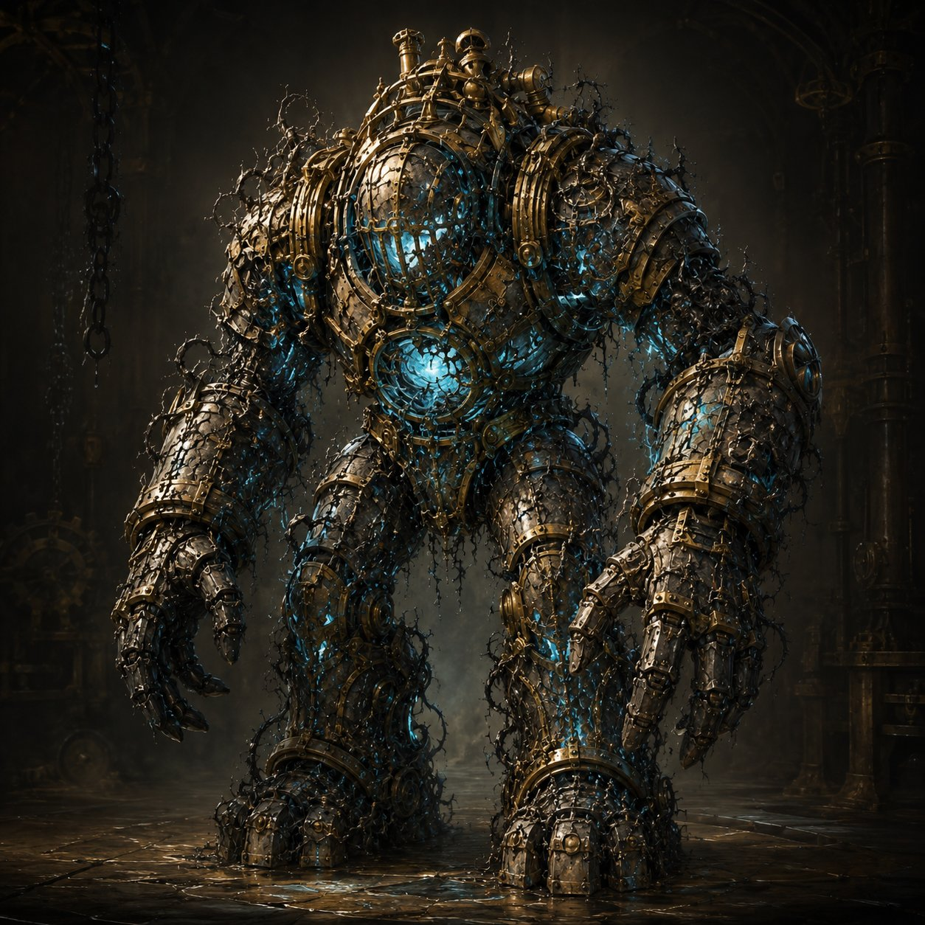  AC 17 HP 68 (8d10+24) Speed 25 ft Init −1  STR 19 DEX 8 CON 17 INT 3 WIS 8 CHA 1  VULNERABLE fire (corrupted wood & vine in its joints — telegraph the smoke!)  Resist nonmagical B/P/S  Imm. (cond) charmed, frightened, exhaustion, poisoned  Senses darkvision 60 ft  Traits  Slow but Unstoppable. Can’t be knocked prone; ignores difficult terrain (tramples flower beds & rubble). It’s slow — heroes can outrun it — but it keeps coming.  Corruption Leak. At 0 HP the blue light gutters out and it slumps — harmless. These were innocent worker-machines; let the kids feel they freed them, not killed them. No death-burst (contrast the market servitors).  Actions  Multiattack. Two Cargo-Arm Slams.  Cargo-Arm Slam. +6 to hit, reach 10 ft. Hit: 2d8+4 bludgeoning.  Sweep (Recharge 5–6). Swings wide; each creature within 10 ft makes a DC 14 Dex save, 2d6+4 bludgeoning on a fail (half on save) and shoved 10 ft. Use it when the party clumps — or to send a hero flying toward danger for drama. | CORRUPTED SPROUTLING  Small plant (planar-corrupted) • 6–8 at once • easy kills  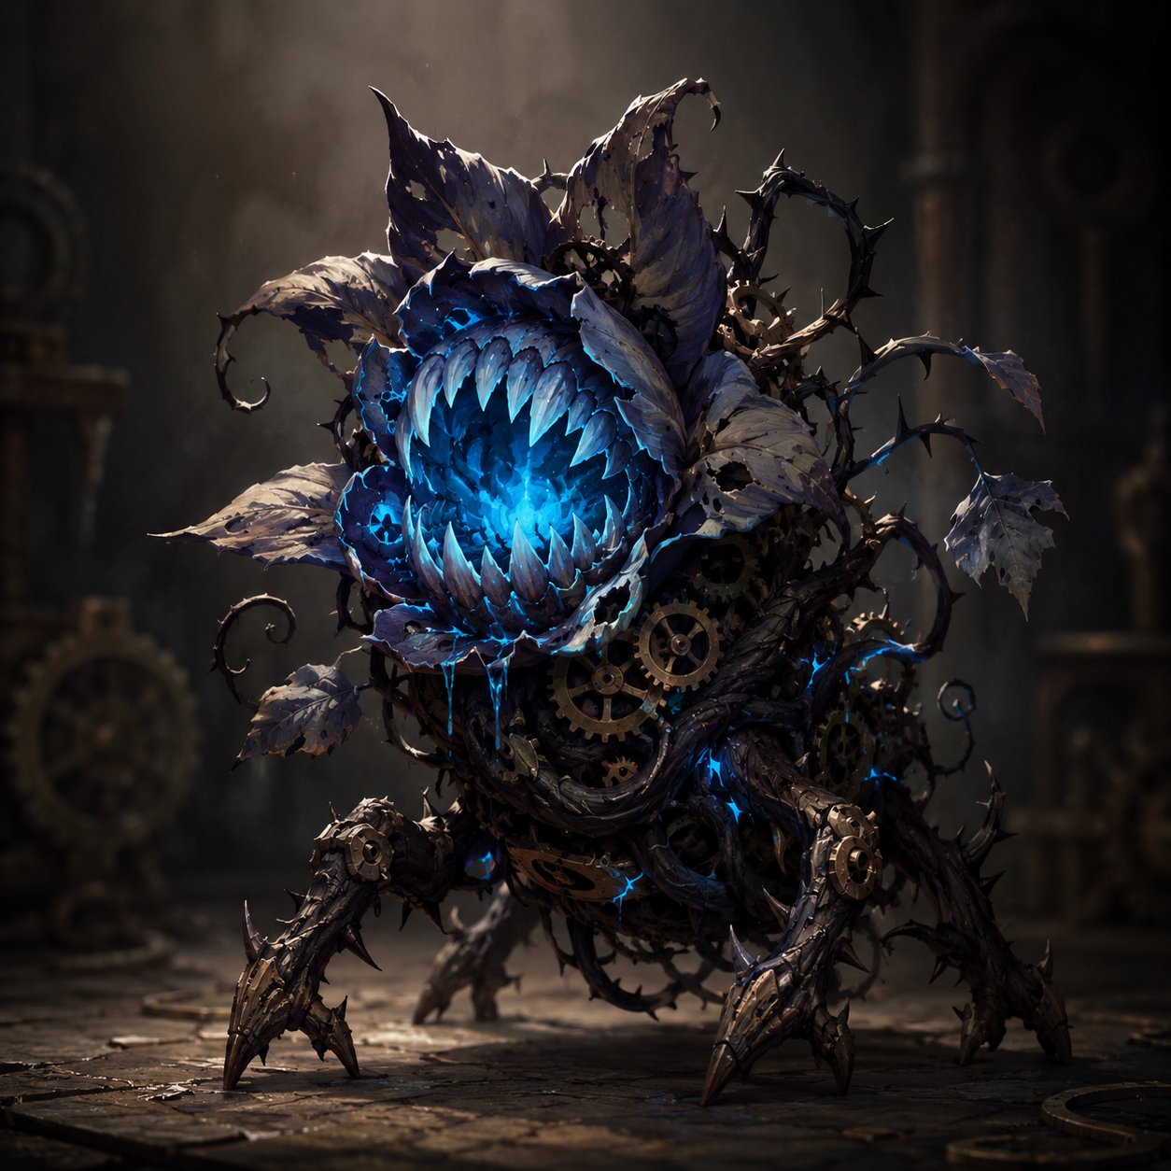  AC 12 HP 7 (2d6) Speed 10 ft, climb 10 ft Init +2  STR 8 DEX 14 CON 10 INT 2 WIS 6 CHA 4  VULNERABLE fire  Senses darkvision 30 ft  Traits  Weak but Many. Dies to almost any solid hit — they exist to be mowed down satisfyingly. An area effect (Lilly’s Thunderwave, Ursa’s Flaming Sphere) clears several at once. Reward AoE.  Group Turn & Spawn. All Sproutlings act together on one shared initiative — roll once, move and attack the whole group at once. Keep 6–8 on the field; when one dies, a new one crawls from a crack on the group’s next turn, until the engine is fixed.  Actions  Thorn-Lash. +4 to hit, reach 5 ft. Hit: 1d6+2 piercing.  Latch. Instead of attacking, grabs on (no damage) — the next attack against that hero has advantage. A way for the little ones to matter without being deadly: they set up the Drudges.
Tactics: Keep it simple and let the kids swing. The three Drudges ring the fountain and block the path to it; keep 6–8 Sproutlings on the field that all act together on one shared turn (topping back up as they die). Mow the little ones down with area attacks for easy, satisfying kills, but the real job is breaking through the Drudge ring to get Lilly to the engine. The Drudges are slow but tanky, hitting hard with Cargo-Arm Slams and a wide Sweep when the party bunches. Both enemy types are VULNERABLE TO FIRE, so reward Lilly’s flamethrower cannon and Ursa’s flame spells. The fight ends the instant Lilly reaches the fountain-engine and stabilizes the surge — every Drudge still standing slumps, harmless. Let a hero drop to 0 if the dice say so; the win is Lilly’s fix, not the body count.
(Running Enemies page — Fight 1’s Rogue Servitor & Cargo Hauler are on the Beat 2 sheet; Fight 2’s Voltcrawler & Broodmother on the Beat 4 sheet. The Grand Custodian boss joins the page in Beat 6.)

